Assignment1-1 Segway

Members:

1,Zhu Chenhao 22320630

2,Liuange 22320627

3,Chen Dongren 22320616

4,YUANJIA 22320617

5,Bie Zhi 22320615

6,Zhang Miaote 22320618

7,Zhang Yichong 22320631

8,Xiong Zhuoen 22320633

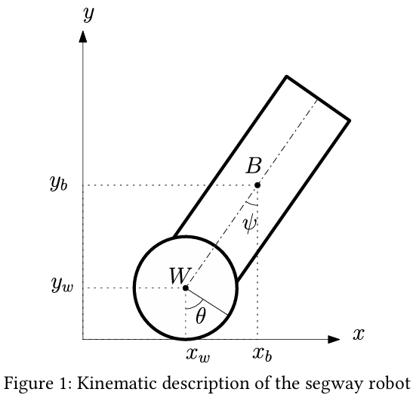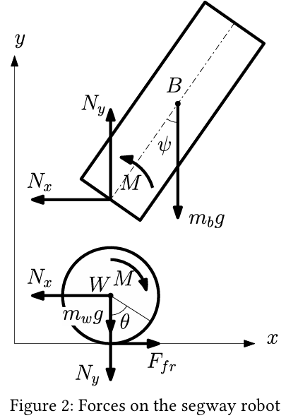

Calculations:

 